**Standard Operating Procedure**

**HEMM &Workshop Maintenance (Mythri Camp)**



**ODISHA MINING CORPORATION LTD.**

**KODINGAMALI BAUXITE MINE**

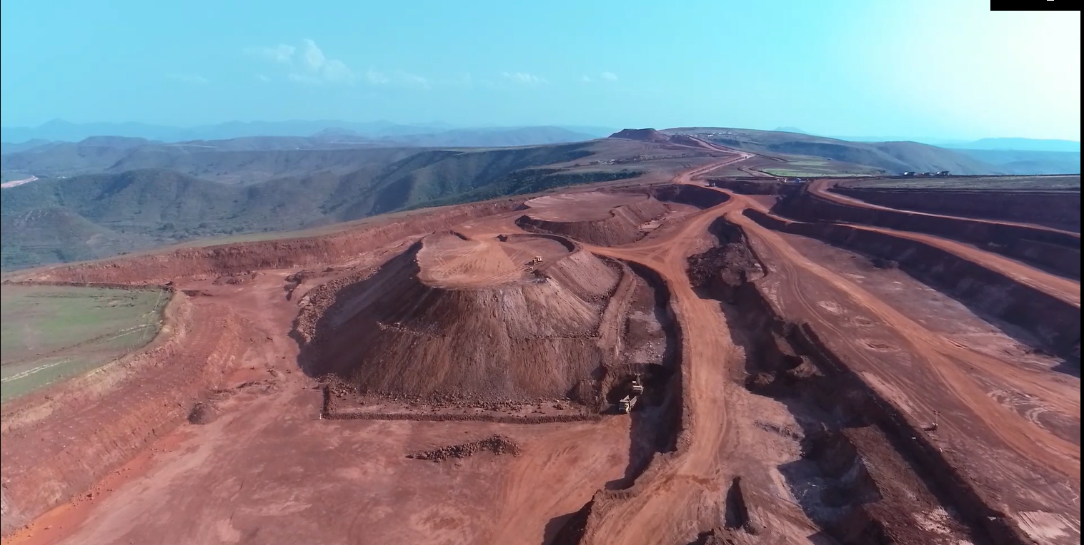

**Authorized By**

**Content**

1. Breakdown working flow and protocol
2. Workshop working procedure and protocols for oil service
3. Points to be followed for safe working by all the responsible position
4. Tyre punctures work flow and protocols
5. Control of Document
6. SOP for Workshop and Mobile Maintenance Van Housekeeping
7. Workshop Emergency Plan
8. Workshop Emergency Management Plan
9. SOP to Carry out service, repair and maintenance activities

|  |
| --- |
| **1. BREAKDOWN WORKING FLOW AND PROTOCOL** |
| * In case of abnormal sound or movement, if found by the operator in the equipment, the operator shall immediately stop the vehicle and escalate the problem to the nearest mining DET/GET present in the operation site. * Then the respective mining DET/GET informs his concerned shift mining manager. * The mining manager does a brief interrogation with the respective operator regarding the vehicle problem. * Then the mining manager contacts the mobile maintenance van shift DET/GET. * The Mobile maintenance van DET/GET asses for a safe parking place parks the breakdown vehicle for maintenance. * After a detailed interrogation with the vehicle operator and thorough inspection of the vehicle, the maintenance van DET/GET instructs the Mechanic to do the specific maintenance job. * The maintenance van DET/GET shall contact his higher mechanical engineering staff if there is a major issue with the vehicle and he shall send the vehicle safely to the workshop. |
|  |
| **2. WORKSHOP WORKING PROCEDURE AND PROTOCOLS FOR OIL SERVICE** |
| * The Scheduled Maintenance Checklist should be regularly checked by a mechanical engineer for the future and immediate oil service required for the all the HEMM working in mines. * If any immediate schedule maintenance is found, the mechanical engineer should contact to store for availability of oil and filter stock. * The mining department should be informed in advance prior to the on which date the maintenance is to be carried out. * On the day of oil service, mechanical engineer should inform the shift in charge. * The shift in charge then informs the mechanic and issues the required filters and oil required for the service. * The mechanic handovers the vehicle key to the shift in charge before starting the schedule maintenance. |
|  |
| **3. POINTS TO BE FOLLOWED FOR SAFE WORKING BY ALL THE RESPONSIBLE POSITION** |
| * The mechanical engineer should provide a replacement vehicle for mining operation during the period of maintenance that is to be carried out to avoid production losses. * The shift in charge shall inspect the vehicle and PPE of all mechanic and Asst mechanic for safe operation. * The shift in charge shall ensure that, the maintenance should complete on time by avoiding delay in work. * The shift in charge shall check the tools and working instrument that are to be used, before the maintenance. |
|  |
| **4. TYRE PUNCTURE WORK FLOW AND PROTOCOLS** |
| * If tyre puncture is found by operator, he should inform to the mining DET/GET . * The mining DET/GET shall inform to the mining manager regarding the tyre puncture of the respective vehicle. * The mining manager informs the Maintenance van DET/GET regarding the tyre puncture. * The maintenance van DET/GET checks the tyre condition and if it is found puncture or bad condition, it is sent to camp by informing the mechanical engineer. * The mechanical engineer informs the shift in charge regarding the puncture. * Then the shift in charge instructs the tyre fitter and tyre mechanic to fit the tyre. |
|  |
| **5. CONTROL OF DOCUMENTS** |
| * All the records are kept in respective register and file * The Register and File are coded as per the standard * All files are with the person responsible is maintained in a database * The Update of each file is recorded in store database * Files are kept in respective rack which are coded as per workshop standards * All documents are regularly updated and frequently inspected by the mechanical I/C for any Non Compliance. |
|  |
| **6. SOP for workshop and Maintenance Vehicle Housekeeping** |
| 1. The cleaning staff should ensured of proper PPE and adhere to the cleaning time. 2. It is mandatory to clean and check the housekeeping checklist. 3. The cleaning staff should follow the do and don’ts of the workshop and adhere to its standard. 4. Apart cleaning staff, the personnel working in the site should ensure of proper tagging, and follow 5S standard to arrange and keep tools, files and materials. 5. The disposal practice for waste oil, tyre, metal scraps, and filter cloth should be used. |
|  |
| **7. Workshop Emergency Management Plan** |
| 1. In case of any emergency in workshop the standard emergency plan for incident to be followed as per mine norms. 2. There is provision for emergency power cut off, exhaust fans, fire point with fire extinguisher at site to be used as applicable. 3. There is display of first aiders who should be approached in case of any first aid injury. 4. The first aid box is available at site which should be used in case of requirement. 5. The display of fire point and first aid box has been plotted in camp layout which can be used to access in case of emergency requirement. 6. There is a Provision of Emergency Escalation Matrix for emergency situation which should be used. 7. In case of any emergency the person should rush to a safe place and then attempt to save the situation as per protocol. |
|  |
| **8. SOP for Tyre Change** |
| **Tyre Change:**  **In case of tyre change requirement following procedures should be followed:**  1. Assessment weather the vehicle can move or not.  2. The vehicle then should be parked in a safe place. If vehicle cannot move towing should be done to park in a safe spot.  3. With proper analysis of tyre the change procedure should commence.  4. The parked vehicle wheel should be properly choked with stopper.  5. Vehicle should be ensured of not in start condition.  6. Required tools should be brought for the operation and should be kept in a designated place before operation.  7. The tyre to be changed should be ensured not in standing condition and to be kept in tyre cage.  8. After the change operation it should be ensured of proper pressure, fitment of bolts, thread should be checked and noted. |
|  |
| **9. SOP to Carry out service, repair and maintenance activities** |
| 1. To be competent, the user/individual on the job must be able to: 2. Ensure OEM recommended procedure and checklist is followed for routine servicing. 3. Ensure the HEMM is always parked (when idle) on flat and firm land, handbrakes applied and buckets pulled down to ground level. 4. Ensure no maintenance work on engine is carried out when the engine is hot and the switch key is plugged in. 5. Disconnect battery for any servicing on the electrical circuit, until and unless advised by electrician. 6. Conduct preventive maintenance at manufacturer prescribed intervals viz. 50 hours, 200 hours, 500 hours, 1000 hours etc. as per the guidelines of the OEM and instructions of his supervisors. 7. Carry out break down maintenance, as and when required, at work site or in workshop, as the case be. 8. Work out the requirements of spare parts, oils & lubricants, coolants, consumables like filter elements, V- belts, etc. 9. Maintain all the relevant records of inspection, maintenance and repairs carried out, on day to day basis. 10. Calibrate, align and adjust settings, alignment, pressures, tension, speeds and levels relevant to:  * engine and aggregates, transmission system * Load bearing arms and structure * Safety devices and components installed * electrical and electronic components * other components (including to valves, ignition, fuel systems and emissions, brakes, transmission, lights, tyres, tracks, hydraulic systems, steering and body/chassis fittings)   11. identify and change components requiring change due to continuous wear and tear including:   * fuel, oil and air filters, oil seals * drive belts, braking system components * drive train components * Bearings and bushes etc.   12. Ensure disposal of materials in accordance with the organization’s policies.  13. Refill correct grade of coolants, lubricants and other fluids as per OEM guidelines.  14. Understand the various precautions to be taken to avoid damage to the vehicle and its components.  15. Record all service and repairs carried out and ensure completeness of tasks assigned before releasing vehicle for the next procedure.  16. Follow standard operating procedures for using workshop tools and equipment.  17. Ensure all workshop tools, equipment and workstations are adequately maintained by carrying out scheduled checks, calibration and timely repairs. |